**Milestone 2 UI Mockups**

Login Page

User Menu

Context Menu

Search bar

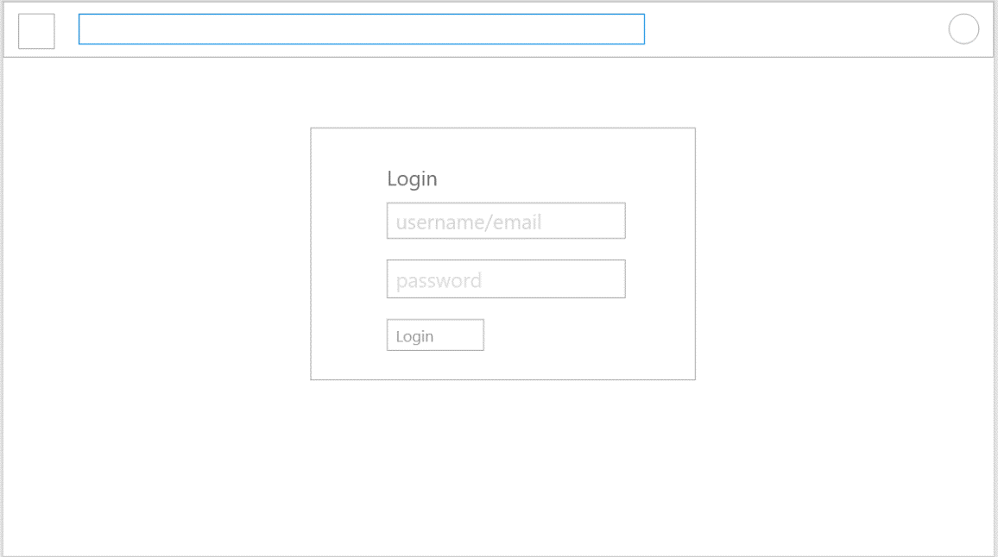

Username Textbox

Navbar

Login Button

Password Textbox

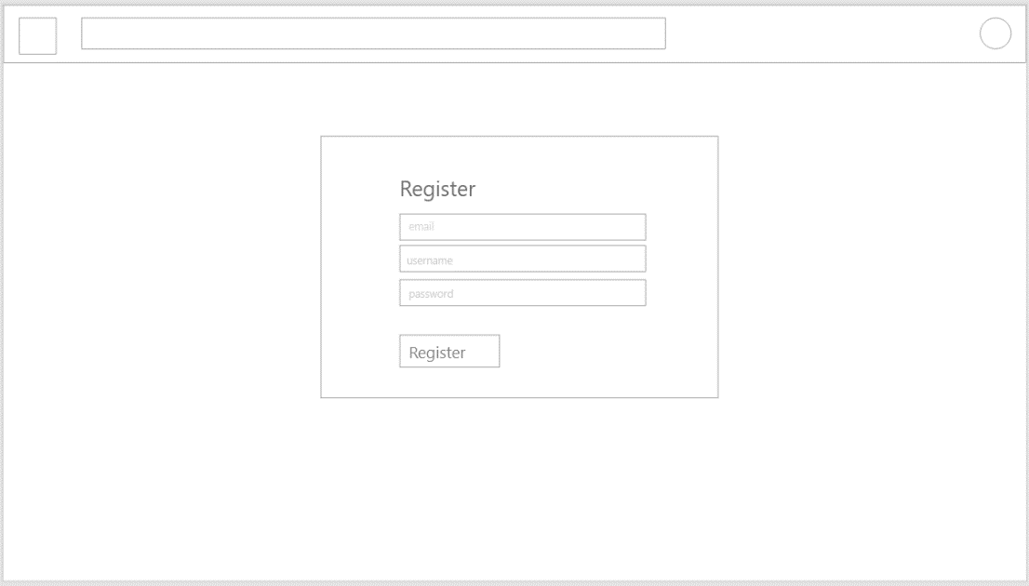Register Page

Username Textbox

Email Textbox

Password Textbox

Register Button

Main Page

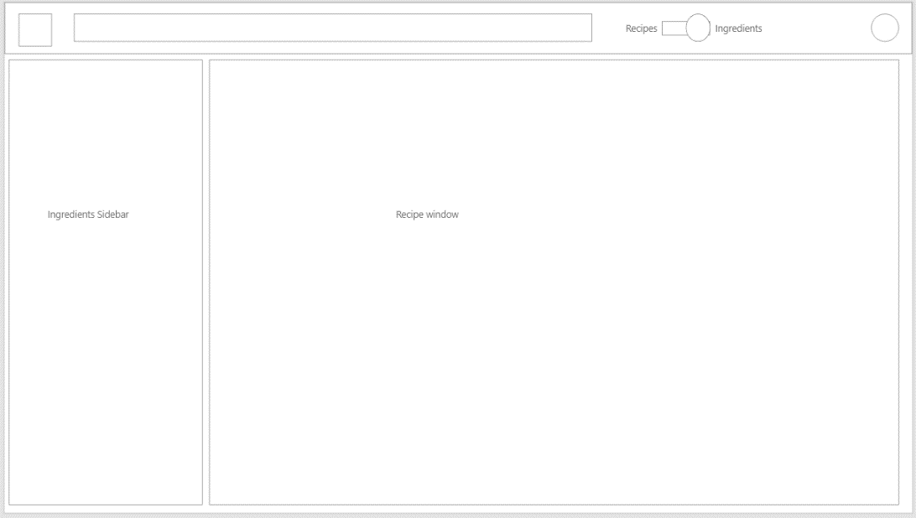

Search Slider

Ingredients Pane

Recipe Pane

Pantry Page

Pantry Pane

List items

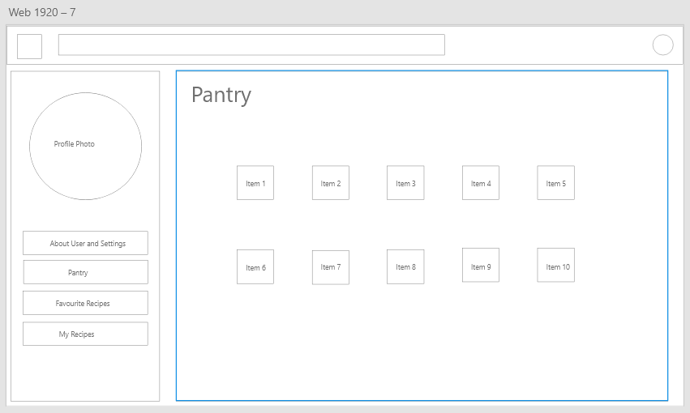

Avatar Picture Box

User settings Button

Pantry Button

Favorite Recipes Button

My Recipes Button

Recipe Page

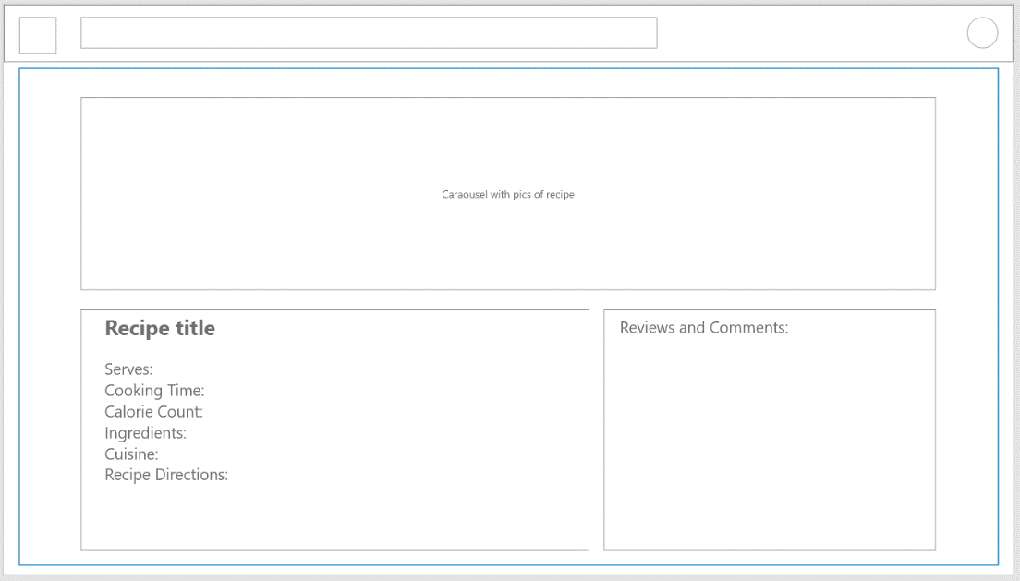

Carousel of Recipe pictures

Recipe Information pane

Reviews and Comments pane

Recipe Creation Page (registered user only)

Calendar counters for cooking time

Serves Numeric Dropdown

Title TextBox

Recipe update pane

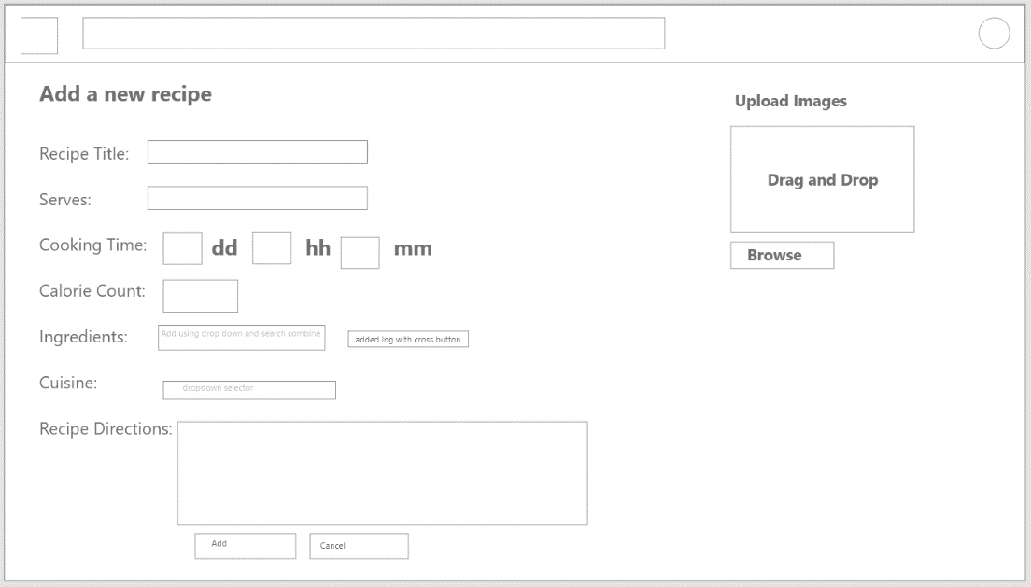

Added Ingredient tags

Numeric dropdown for calories

Ingredients Search bar

Browse Pictures button

Drag control for pictures

Cuisine dropdown

Cancel Button

Add Button

Instructions TextBox

Profile Page

Firstname Textbox

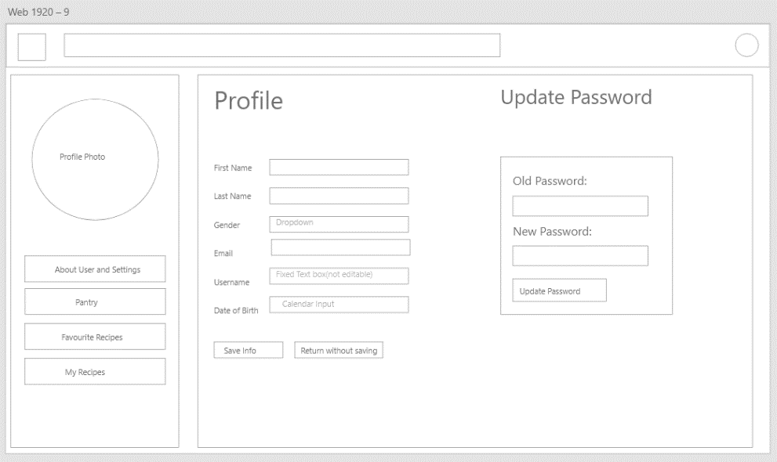

DOB Calendar control

Username Textbox Undeditable

Email Textbox

Gender Dropdown

Lastname Textbox

Cancel Button

Save button

Old Pass textbox

Password Pane

Update Button

New pass Textbox

Favorite Recipes Page

Favourites Pane

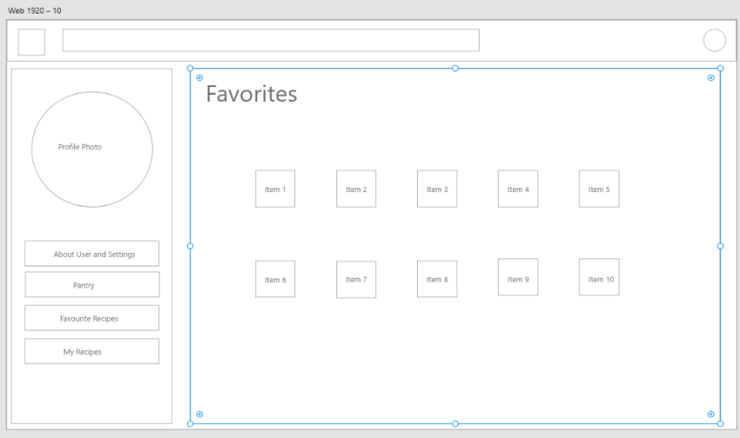

List Items as Favorites

My Recipes Page

List Items of all Recipes

My Recipes Pane

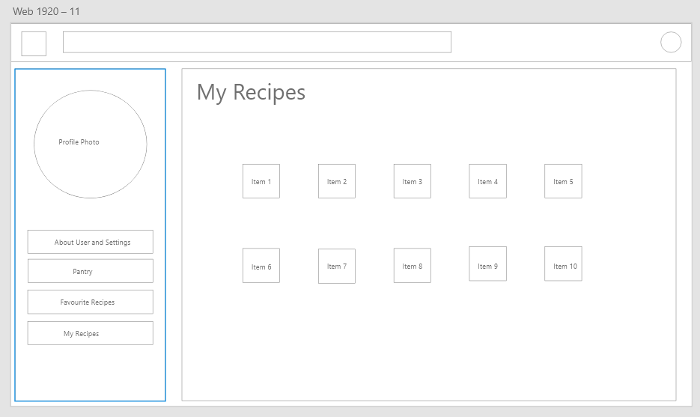

Recommendations Page

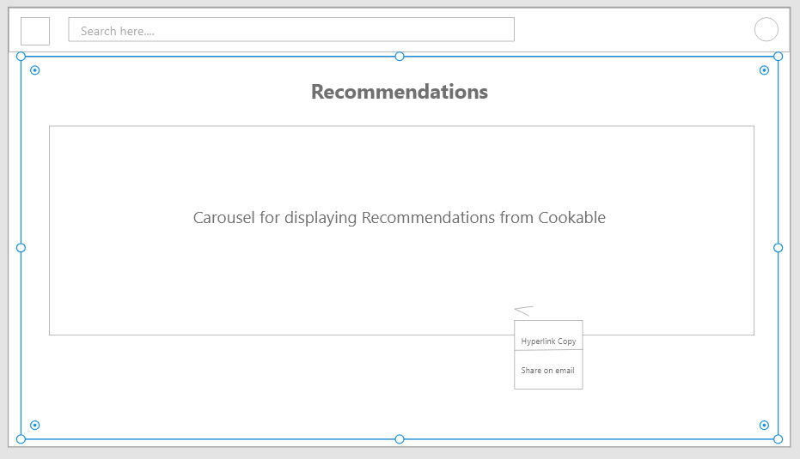

Recipe recommended carousel

Share Button

Share Drop down

Menus on Nav Bar

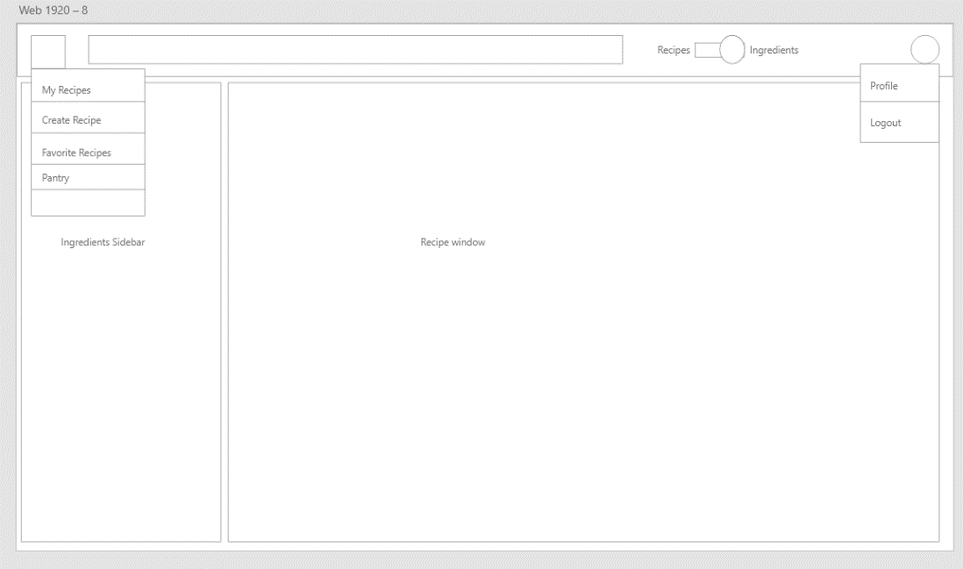

Site Menu Dropdown

With Redirections

User Menu Dropdown with redirections

Search Window with results

Search results as list items

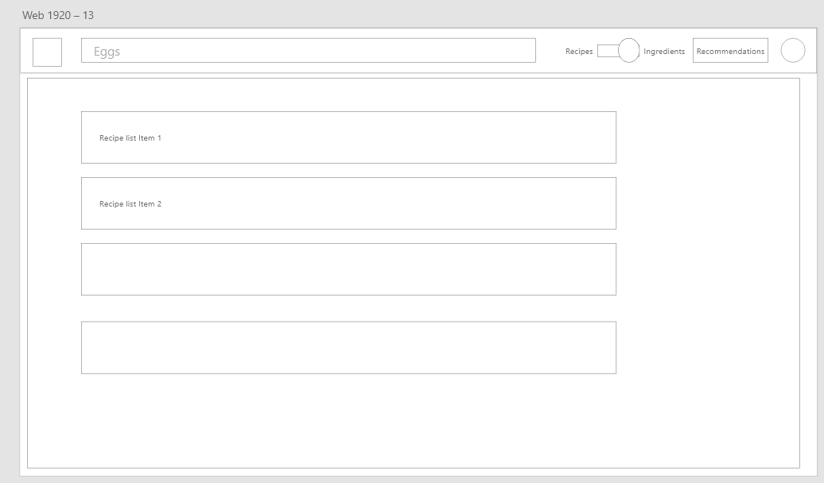

Ingredients Page:

Shop from list items

Ingredients details pane

